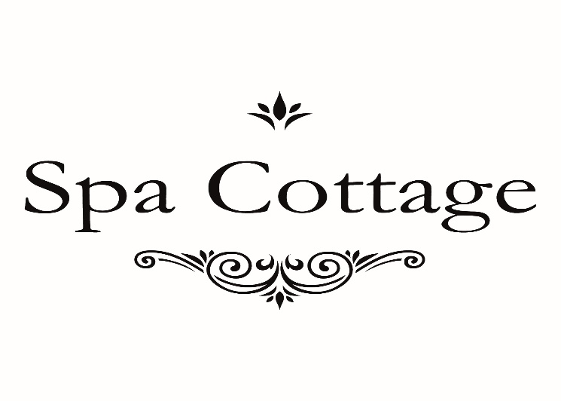

LIPO LASE
£55 FOR ONE AREA

Terms and conditions apply.

