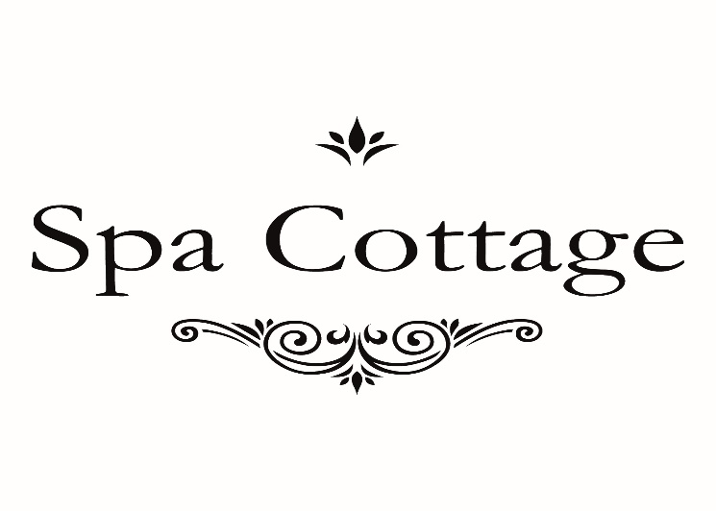

£50 off CACI Face Course when booked in with our senior therapist Sammie.

This offer is valid from 8th November 2016 for a limited time only.

