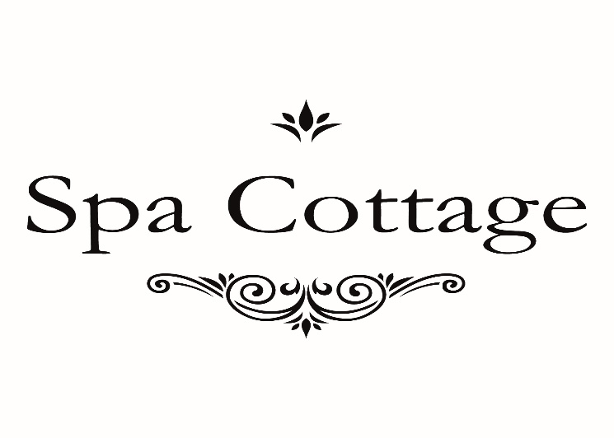

WHEN BOOKING IN FOR ½ MICRO RECEIVE A FREE MASK.

Terms and Conditions Apply to this offer. Please download this voucher or show offer on your smart phone.

